Elaboration Phase Spec

Swiftriver

**System Requirements** **4**

**Use Case Diagram** **5**

**Trace Matrix** **7**

**Use Cases & Sequence Diagrams** **7**

Use Case: Add Donor Profile 8

Use Case: Modify Donor 8

Use Case: Delete Donor 9

Use Case: Login Donor Profile 10

Use Case: Add One Time Donation 11

Use Case: Add Recurring Donation 12

Use Case: Modify Donation 13

Use Case: Delete Recurring Donation 14

Use Case: View Donations 15

Use Case: Add Child 16

Use Case: Modify Child 17

Use Case: Delete Child 18

Use Case: Add Volunteer 19

Use Case: Modify Volunteer 20

Use Case: Delete Volunteer 21

Use Case: Add Volunteer Hours 22

Use Case: Modify Volunteer Hours 23

Use Case: Delete Volunteer Hours 24

Use Case: Register Volunteer 25

Use Case: Add Event to Calendar 26

Use Case: Modify Event to Calendar 27

Use Case: Delete Event to Calendar 28

Use Case: View Calendar of Events 29

Use Case: Add Fundraising Profits 30

Use Case: Modify Fundraising Profits 31

Use Case: Delete Fundraising Profits 32

Use Case: Add Silent Auction Item 33

Use Case: Modify Silent Auction Item 34

Use Case: Delete Silent Auction Item 35

Use Case: View Item 36

Use Case: Add Silent Auction Item Sale 37

Use Case: Modify Silent Auction Item Sale 38

Use Case: Delete Silent Auction Item Sale 39

Use Case: Add Summer Camp Application 40

Use Case: Modify Summer Application 43

Use Case: Delete Summer Camp Application 47

Use Case: View Summer Camp Application 48

Use Case: Add Summer Camp Event 49

Use Case: Modify Summer Camp Event 51

Use Case: Delete Summer Camp Event 53

Use Case: View Summer Camp Event 54

Use Case: Add Horse Data 55

Use Case: Modify Horse Data 56

Use Case: Delete Horse Data 57

Use Case: View Horse Data 58

Use Case: Add Pictures 59

Use Case: Modify Pictures 60

Use Case: Delete Pictures 61

Use Case: Add Newsletter 62

Use Case: Modify Newsletter 63

Use Case: Delete Newsletter 64

Use Case: View Newsletter 65

Use Case: Add Board of Directors Member 66

Use Case: Modify Board of Directors Member 67

Use Case: Delete Board of Directors Member 68

Use Case: View Board of Directors 69

**Class Diagram** **70**

**Database design and data definitions** **71**

Camper Record 73

Summer Camp Event 75

Volunteer Record 76

Picture Record 77

Board of Directors Record 78

Newsletter Record 79

Item Record 80

Grant Record 81

Item Sale Record 82

Events 83

Fundraising 84

Horse Data 85

**User Interface Navigation Diagram and Screen Layouts** **86**

**Physical Architecture Design** **87**

Realization View 87

**Design Procedures for Security Concerns and Non-functional Requirements** **88**

**Gantt Chart** **89**

**Elaboration Phase Prototype** **90**

Add/Modify Camper Record 90

Delete Camper Record 91

Add/Modify Summer Camp Event 92

Delete Summer Camp Event 93

View Summer Camp Event 94

Add Volunteer Record 95

Modify Volunteer 96

Delete Volunteer 97

Add/Modify/ Delete Events 98

View Events 99

View Horse Data 100

Newsletter 101

Pictures 102

Board of Directors 103

# 

# 

# 

# System Requirements

System Requirements in “will” format:

1. The central database system shall have all the information in one place to save both time and money.
2. The electronic donation system shall be implemented through the website to increase cash flow.
3. The data backup system shall keep all data secured in case of data loss.
4. The marketing system shall find and attract new donors and volunteers for the organization.
5. The social media system shall enable the organization to reach out to possible donors and provide a source of marketing for free.
6. The new volunteer information / sign-up system shall enable more volunteers to sign up and find more information about the organization.
7. The easier communication system shall provide a method of communication between employees to improve efficiency.
8. The event management system shall allow both employees and users of the website to find out information about upcoming events.
9. The merchandising system shall create a new revenue stream, as well as provide free advertising with labeled products.

# 

# 

# 

# 

# 

# 

# Use Case Diagram

How to Read Use Case Diagram: Shows which part of the Use Cases the actor interacts with.

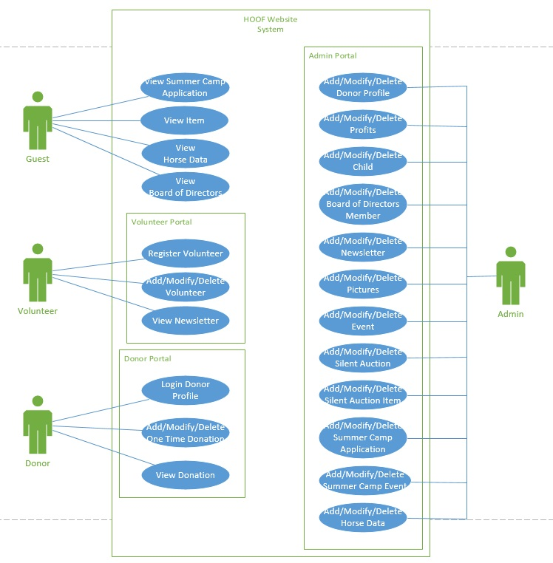

# Trace Matrix

How to Read Trace Matrix: The trace matrix shows the related use case ID and its system requirements in order to function.

# 

# Use Cases & Sequence Diagrams

## Use Case: Add Donor Profile

|  |  |
| --- | --- |
| ID: | 1.A |
| Use Case Name: | Add Donor Profile |
| Primary Actor(s): | Donor |
| Risk Level: | Low |
| Description: | This use case shows how a donor can register for an account |
| Precondition: | Donor is hoofky.org and is in register account page. |
| Postcondition: | Donor profile is created |

|  |  |
| --- | --- |
| Main Flow | Sequence Diagram |
| * User clicks “sign in/register” * User enters username * User enters password * User enters password again * User enters personal information * User clicks “register account” * Account is registered * Use case ends |  |

## Use Case: Modify Donor

|  |  |
| --- | --- |
| ID: | 1.B |
| Use Case Name: | Modify Donor |
| Primary Actor(s): | Donor |
| Risk Level: | Low |
| Description: | This use case shows how a donor can modify their profile page and account information. |
| Precondition: | Donor is signed into hoofky.org |
| Postcondition: | Donor’s profile page and information is modified. |

|  |  |
| --- | --- |
| Main Flow | Sequence Diagram |
| * User clicks on “sign in/register” * User enters username * User enters password * User clicks “sign in” * User clicks “update/delete account” * User modifies information * User clicks “update” * Use case ends |  |

## Use Case: Delete Donor

|  |  |
| --- | --- |
| ID: | 1.C |
| Use Case Name: | Delete Donor |
| Primary Actor(s): | Donor |
| Risk Level: | Low |
| Description: | This use case shows how a donor can delete their account. |
| Precondition: | Donor is signed into hoofky.org |
| Postcondition: | Donor account is deleted. |

|  |  |
| --- | --- |
| Main Flow | Sequence Diagram |
| * User clicks on “sign in/register” * User enters username * User enters password * User clicks “sign in” * User clicks “update/delete account” * User clicks “delete account” * User clicks “confirm delete” * Use case ends |  |

## Use Case: Login Donor Profile

|  |  |
| --- | --- |
| ID: | 1.D |
| Use Case Name: | Login Donor Profile |
| Primary Actor(s): | Donor |
| Risk Level: | Low |
| Description: | This use case shows how a donor can log into their account in hoofky.org. |
| Precondition: | Donor is in hoofky.org |
| Postcondition: | Donor is logged into their account. |

|  |  |
| --- | --- |
| Main Flow | Sequence Diagram |
| * User clicks on “sign in/register” * User enters username * User enters password * User clicks “sign in” * Use case ends |  |

## Use Case: Add One Time Donation

|  |  |
| --- | --- |
| ID: | 2.A |
| Use Case Name: | Add One Time Donation |
| Primary Actor(s): | User |
| Risk Level: | High |
| Description: | This use case shows how a user can make a one time donation through paypal. |
| Precondition: | User is in hoofky.org and is in the donation page. |
| Postcondition: | User makes a one time donation. |

|  |  |
| --- | --- |
| Main Flow | Sequence Diagram |
| * User clicks “Donate Now” button * User clicks “Log In With PayPal” button * User enters PayPal credentials * User verifies one-time transaction * User is redirected back to HOOF website * Use case ends |  |

## Use Case: Add Recurring Donation

|  |  |
| --- | --- |
| ID: | 2.B |
| Use Case Name:: | Add Recurring Donation |
| Primary Actor(s): | User |
| Risk Level: | High |
| Description: | This use case shows how to make a recurring donation through paypal. |
| Precondition: | User is hoofy.org and is in the donation page. |
| Postcondition: | User makes a recurring donation. |

|  |  |
| --- | --- |
| Main Flow | Sequence Diagram |
| * User clicks “Donate Now” button * User clicks “Log In With PayPal” button * User enters PayPal credentials * User verifies recurring transaction * User is redirected back to HOOF website * Use case ends |  |

## Use Case: Modify Donation

|  |  |
| --- | --- |
| ID: | 2.C |
| Use Case Name: | Modify Recurring Donation |
| Primary Actor(s): | User |
| Risk Level: | High |
| Description: | This use case shows a user can modify their donation amount. |
| Precondition: | User is logged into their paypal account. |
| Postcondition: | User modifies donation amount. |

|  |  |
| --- | --- |
| Main Flow | Sequence Diagram |
| * User clicks “Donate Now” button * User clicks “Log In With PayPal” button * User enters PayPal credentials * User clicks “Profile” * User clicks “My Money” * User clicks “Update” * User selects recurring payment * User clicks “Change Amount” * User inputs donation amount * User clicks “Submit” * User is redirected to HOOF website * Use case ends |  |

## Use Case: Delete Recurring Donation

|  |  |
| --- | --- |
| ID: | 2.D |
| Use Case Name: | Delete Recurring Donation |
| Primary Actor(s): | User |
| Risk Level: | High |
| Description: | This use case shows how a user can delete their recurring donation on paypal. |
| Precondition: | User is logged into their paypal account. |
| Postcondition: | User’s recurring payment is deleted. |

|  |  |
| --- | --- |
| Main Flow | Sequence Diagram |
| * User clicks “Donate Now” button * User clicks “Log In With PayPal” button * User enters PayPal credentials * User clicks “Profile” * User clicks “My Money” * User clicks “Update” * User selects recurring payment * User clicks “Cancel” * User is redirected to HOOF website * Use case ends |  |

## Use Case: View Donations

|  |  |
| --- | --- |
| ID: | 2.E |
| Use Case Name: | View donations |
| Primary Actor(s): | User |
| Risk Level: | High |
| Description: | This use case shows how a user can view their donation history. |
| Precondition: | User is in logged into their paypal account. |
| Postcondition: | User views their donation history. |

|  |  |
| --- | --- |
| Main Flow | Sequence Diagram |
| * User clicks “Donate Now” button * User clicks “Log In With PayPal” button * User enters PayPal credentials * User clicks “Activity” on navigation bar * Use case ends |  |

## Use Case: Add Child

|  |  |
| --- | --- |
| ID: | 3.A |
| Use Case Name: | Add Child |
| Primary Actor(s): | Admin |
| Risk Level: | High |
| Description: | This Use Case shows how a child is added to the HOOF system |
| Precondition: | Admin is logged into the database |
| Postcondition: | Child is added to the HOOF system |

|  |  |
| --- | --- |
| Main Flow | Sequence Diagram |
| * Admin adds Child’s first name * Admin adds Child’s middle initial * Admin adds Child’s last name * Admin adds Child’s age * Admin adds Child’s gender * Admin adds Child’s ethnicity * Admin adds summer camp month * Admin adds summer camp year * Admin adds summer camp name * Admin adds agency * Admin adds t-shirt size * Admin submits * Use Case ends |  |

## Use Case: Modify Child

|  |  |
| --- | --- |
| ID: | 3.B |
| Use Case Name: | Modify Child |
| Primary Actor(s): | Admin |
| Risk Level: | High |
| Description: | This Use Case shows how a child is modified in the HOOF system |
| Precondition: | Admin is logged into the database |
| Postcondition: | Child is modified to the HOOF system |

|  |  |
| --- | --- |
| Main Flow | Sequence Diagram |
| * Admin edits Child’s first name * Admin edits Child’s last name * Admin edits Child’s middle initial * Admin edits Child’s age * Admin edits Child’s gender * Admin edits Child’s ethnicity * Admin edits summer camp month * Admin edits summer camp year * Admin edits summer camp name * Admin edits agency name * Admin edits t-shirt size * Admin submits changes * Use Case ends |  |

## Use Case: Delete Child

|  |  |
| --- | --- |
| ID: | 3.C |
| Use Case Name: | Delete Child |
| Primary Actor(s): | Admin |
| Risk Level: | High |
| Description: | This Use Case shows how a child is deleted from the HOOF system |
| Precondition: | Admin is logged into the database |
| Postcondition: | Child is deleted from the HOOF system |

|  |  |
| --- | --- |
| Main Flow | Sequence Diagram |
| * Admin selects child * Admin deletes selection * Pop-up confirmation window * Admin clicks yes * Child deleted from system * Use Case ends |  |

## Use Case: Add Volunteer

|  |  |
| --- | --- |
| ID: | 4.A |
| Use Case Name: | Add Volunteer |
| Primary Actor(s): | Admin |
| Risk Level: | Low |
| Description: | This Use Case shows how a volunteer is added to the HOOF system |
| Precondition: | Admin is logged into the database |
| Postcondition: | Volunteer is added to the HOOF system |

|  |  |
| --- | --- |
| Main Flow | Sequence Diagram |
| * Admin adds Volunteer’s first name * Admin adds Volunteer’s Last Name * Admin adds Volunteer’s address * Admin adds Volunteer’s city * Admin adds Volunteer’s state * Admin adds Volunteer’s zip code * Admin adds Volunteer’s phone number * Admin submits * Volunteer is added * Use Case ends |  |

## Use Case: Modify Volunteer

|  |  |
| --- | --- |
| ID: | 4.B |
| Use Case Name: | Modify Volunteer |
| Primary Actor(s): | Admin |
| Risk Level: | Low |
| Description: | This Use Case shows how a volunteer is modified the HOOF system |
| Precondition: | Admin is logged into the database |
| Postcondition: | Volunteer is modified in the HOOF system |

|  |  |
| --- | --- |
| Main Flow | Sequence Diagram |
| * Admin edits Volunteer’s first name * Admin edits Volunteer’s Last Name * Admin edits Volunteer’s address * Admin edits Volunteer’s city * Admin edits Volunteer’s state * Admin edits Volunteer’s zip code * Admin edits Volunteer’s phone number * Admin submits * Volunteer is modified * Use Case ends |  |

## Use Case: Delete Volunteer

|  |  |
| --- | --- |
| ID: | 4.C |
| Use Case Name: | Delete Volunteer |
| Primary Actor(s): | Admin |
| Risk Level: | Low |
| Description: | This Use Case shows how a volunteer is deleted from the HOOF system |
| Precondition: | Admin is logged into the database |
| Postcondition: | Volunteer is deleted from the HOOF system |

|  |  |
| --- | --- |
| Main Flow | Sequence Diagram |
| * Admin selects volunteer * Admin deletes selection * Pop-up confirmation window * Admin clicks yes * Child deleted from system * Use Case ends |  |

## Use Case: Add Volunteer Hours

|  |  |
| --- | --- |
| ID: | 5.A |
| Use Case Name: | Add Volunteer Hours |
| Primary Actor(s): | Volunteer |
| Risk Level: | Low |
| Description: | This Use Case shows how a volunteer adds hours to the HOOF system |
| Precondition: | Volunteer is logged into their account on hoofky.org |
| Postcondition: | Hours are added to the HOOF system |

|  |  |
| --- | --- |
| Main Flow | Sequence Diagram |
| * Volunteer clicks “edit” on hours in profile * Volunteer adds hours * Volunteer selects date * Volunteer clicks “submit” * Hours are added to the HOOF system * Use Case ends |  |

## Use Case: Modify Volunteer Hours

|  |  |
| --- | --- |
| ID: | 5.B |
| Use Case Name: | Modify Volunteer Hours |
| Primary Actor(s): | Volunteer |
| Risk Level: | Low |
| Description: | This Use Case shows how a volunteer edits hours from the HOOF system |
| Precondition: | Volunteer is logged into their account on hoofky.org |
| Postcondition: | Hours are edited in the HOOF system |

|  |  |
| --- | --- |
| Main Flow | Sequence Diagram |
| * Volunteer clicks “edit” on hours in profile * Volunteer edits hours * Volunteer selects date * Volunteer clicks “submit” * Hours are edited in the HOOF system * Use Case ends |  |

## Use Case: Delete Volunteer Hours

|  |  |
| --- | --- |
| ID: | 5.C |
| Use Case Name: | Delete Volunteer Hours |
| Primary Actor(s): | Volunteer |
| Risk Level: | Low |
| Description: | This Use Case shows how a volunteer deletes hours from the HOOF system |
| Precondition: | Volunteer is logged into their account on hoofky.org |
| Postcondition: | Hours are deleted the HOOF system |

|  |  |
| --- | --- |
| Main Flow | Sequence Diagram |
| * Volunteer clicks “edit” on hours in profile * Volunteer deletes hours * Volunteer selects date * Volunteer clicks “submit” * Hours are deleted in the HOOF system * Use Case ends |  |

## Use Case: Register Volunteer

|  |  |
| --- | --- |
| ID: | 5.D |
| Use Case Name: | Register Volunteer |
| Primary Actor(s): | Volunteer |
| Risk Level: | Low |
| Description: | This use case describes how a volunteer creates a profile in the HOOF system |
| Precondition: | Volunteer is in hoofky.org |
| Postcondition: | A volunteer profile is created |

|  |  |
| --- | --- |
| Main Flow | Sequence Diagram |
| * Volunteer clicks “Become A Volunteer” * Volunteer adds email * Volunteer adds password * Volunteer adds first name * Volunteer adds last name * Volunteer adds address * Volunteer adds city * Volunteer adds zip code * Volunteer adds phone number * Volunteer clicks “Submit” * Volunteer profile is created * Use Case ends |  |

## Use Case: Add Event to Calendar

|  |  |
| --- | --- |
| ID: | 6.A |
| Use Case Name: | Add Event to Calendar |
| Primary Actor(s): | Admin |
| Risk Level: | Low |
| Description: | This use case describes how an admin can add an event to the event calendar. |
| Precondition: | Admin login |
| Postcondition: | Event is added |

|  |  |
| --- | --- |
| Main Flow | Sequence Diagram |
| * Admin clicks on “My Site” to open hoofky.org editor. * Admin clicks on “Customize.” * Admin clicks on “Events” menu button. * Admin clicks on blue edit icon. * Admin can add event information to calendar * Admin clicks “Publish.” * Calendar is updated * Use case ends |  |

## 

## Use Case: Modify Event to Calendar

|  |  |
| --- | --- |
| ID: | 6.B |
| Use Case Name:: | Modify Event to Calendar |
| Primary Actor(s): | Admin |
| Risk Level: | Low |
| Description: | This use case describes how an admin can modify an event on the event calendar. |
| Precondition: | Admin login |
| Postcondition: | Event is modified |

|  |  |
| --- | --- |
| Main Flow | Sequence Diagram |
| * Admin clicks on “My Site” to open hoofky.org editor. * Admin clicks on “Customize.” * Admin clicks on “Events” menu button. * Admin clicks on blue edit icon. * Admin can edit event that has been added * Admin clicks “Publish.” * Calendar is updated * Use case ends |  |

## Use Case: Delete Event to Calendar

|  |  |
| --- | --- |
| ID: | 6.C |
| Use Case Name: | Delete Event to Calendar |
| Primary Actor(s): | Admin |
| Risk Level: | Low |
| Description: | This use case describes how an admin can delete an event on the event calendar. |
| Precondition: | Admin login |
| Postcondition: | Event is modified |

|  |  |
| --- | --- |
| Main Flow | Sequence Diagram |
| * Admin clicks on “My Site” to open hoofky.org editor. * Admin clicks on “Customize.” * Admin clicks on “Events” menu button. * Admin clicks on blue edit icon. * Admin selects an existing event. * Admin clicks “Delete Event” * Admin can delete event information from calendar * Admin clicks “Publish.” * Calendar is updated * Use case ends |  |

## Use Case: View Calendar of Events

|  |  |
| --- | --- |
| ID: | 6.D |
| Use Case Name: | View Calendar of Events |
| Primary Actor(s): | User |
| Risk Level: | Low |
| Description: | This use case describes how user can view events. |
| Precondition: | User login |
| Postcondition: | None |

|  |  |
| --- | --- |
| Main Flow | Sequence Diagram |
| * User clicks events on the homepage * User is directed to event page * Calendar with events is visible on the bottom right * Use case ends |  |

## Use Case: Add Fundraising Profits

|  |  |
| --- | --- |
| ID: | 7.A |
| Use Case Name: | Add Fundraising Profits |
| Primary Actor(s): | Admin |
| Risk Level: | High |
| Description: | This use case describes how an admin can add profit from fundraising events. |
| Precondition: | Admin login |
| Postcondition: | Funds are added |

|  |  |
| --- | --- |
| Main Flow | Sequence Diagram |
| * Admin clicks on “My Site” to open hoofky.org editor. * Admin clicks on “Funds” * Admin clicks on “View Funds” menu button. * Admin clicks on add icon * Admin enters amount to add * Admin clicks “Publish.” * Funds will be updated * Use case ends |  |

## Use Case: Modify Fundraising Profits

|  |  |
| --- | --- |
| ID: | 7.B |
| Use Case Name: | Modify Fundraising Profits |
| Primary Actor(s): | Admin |
| Risk Level: | High |
| Description: | This use case describes how an admin can modify profit from fundraising events. |
| Precondition: | Admin login |
| Postcondition: | Funds is modified |

|  |  |
| --- | --- |
| Main Flow | Sequence Diagram |
| * Admin clicks on “My Site” to open hoofky.org editor. * Admin clicks on “Funds” * Admin clicks on “View Funds” menu button. * Admin clicks on modify icon * Admin enters amount modified * Admin clicks “Publish.” * Funds will be updated * Use case ends |  |

## Use Case: Delete Fundraising Profits

|  |  |
| --- | --- |
| ID: | 7.C |
| Use Case Name: | Delete Fundraising Profits |
| Primary Actor(s): | Admin |
| Risk Level: | High |
| Description: | This use case describes how an admin can delete profit from fundraising events. |
| Precondition: | Admin login |
| Postcondition: | Funds are deleted |

|  |  |
| --- | --- |
| Main Flow | Sequence Diagram |
| * Admin clicks on “My Site” to open hoofky.org editor. * Admin clicks on “Funds” * Admin clicks on “View Funds” menu button. * Admin clicks on delete icon. * Admin enters amount to delete * Admin clicks “Publish.” * Funds will be updated * Use case ends |  |

## Use Case: Add Silent Auction Item

|  |  |
| --- | --- |
| ID: | 8.A |
| Use Case Name: | Add Silent Auction Item |
| Primary Actor(s): | Admin |
| Risk Level: | Low |
| Description: | This use case describes how an admin can add a silent auction item. |
| Precondition: | Admin has logged into WordPress. |
| Postcondition: | The new item has been added to the silent auction. |

|  |  |
| --- | --- |
| Main Flow | Sequence Diagram |
| * Admin clicks on “My Site” to open hoofky.org editor. * Admin clicks on “Customize”. * Admin creates new silent auction item. * Admin clicks “Publish”. * Admin logs off WordPress. * Use case ends. |  |

## Use Case: Modify Silent Auction Item

|  |  |
| --- | --- |
| ID: | 8.B |
| Use Case Name: | Modify Silent Auction Item |
| Primary Actor(s): | Admin |
| Risk Level: | Low |
| Description: | This use case describes how an admin can modify a silent auction item. |
| Precondition: | Admin has logged into WordPress |
| Postcondition: | Silent Auction Item has been modified. |

|  |  |
| --- | --- |
| Main Flow | Sequence Diagram |
| * Admin clicks on “My Site” to open hoofky.org editor. * Admin clicks on “Customize”. * Admin modifies silent auction item. * Admin clicks “Publish”. * Admin logs off WordPress. * Use case ends. |  |

## Use Case: Delete Silent Auction Item

|  |  |
| --- | --- |
| ID: | 8.C |
| Use Case Name: | Delete Silent Auction Item |
| Primary Actor(s): | Admin |
| Risk Level: | Low |
| Description: | This use case describes how an admin can delete a silent auction item. |
| Precondition: | Admin has logged into WordPress |
| Postcondition: | Silent Auction Item has been deleted. |

|  |  |
| --- | --- |
| Main Flow | Sequence Diagram |
| * Admin clicks on “My Site” to open hoofky.org editor. * Admin clicks on “Customize”. * Admin deletes silent auction item. * Admin clicks “Publish”. * Admin logs off WordPress. * Use case ends. |  |

## Use Case: View Item

|  |  |
| --- | --- |
| ID: | 8.D |
| Use Case Name: | View silent auction item |
| Primary Actor(s): | User |
| Risk Level: | Low |
| Description: | This use case describes how a user can view silent auction items. |
| Precondition: | User is on hoofky.org. |
| Postcondition: | User views desired item. |

|  |  |
| --- | --- |
| Main Flow | Sequence Diagram |
| * User clicks on “Silent Auction” page. * User clicks on “Items Offered”. * User clicks on desired item. * Use case ends. |  |

## Use Case: Add Silent Auction Item Sale

|  |  |
| --- | --- |
| ID: | 9.A |
| Use Case Name: | Add silent auction item sale. |
| Primary Actor(s): | Admin |
| Risk Level: | High |
| Description: | This use case describes how an admin can add a silent auction item sale. |
| Precondition: | Admin has logged into hoofky.org |
| Postcondition: | Silent Auction Item has been modified. |

|  |  |
| --- | --- |
| Main Flow | Sequence Diagram |
| * Admin clicks on “Record Item Sale” * Admin enters item date of sale. * Admin enters price. * Admin enters buyer. * Admin clicks “Submit” * Use case ends. |  |

## Use Case: Modify Silent Auction Item Sale

|  |  |
| --- | --- |
| ID: | 9.B |
| Use Case Name: | Modify Silent Auction Item Sale |
| Primary Actor(s): | Admin |
| Risk Level: | High |
| Description: | This use case describes how an admin can modify a silent auction item sale. |
| Precondition: | Admin has logged into hoofky.org |
| Postcondition: | Silent Auction Item Sale has been modified. |

|  |  |
| --- | --- |
| Main Flow | Sequence Diagram |
| * Admin clicks on “Modify/Delete Item Sale” * Admin selects desired Item. * Admin modifies data. * Admin clicks “Submit” * Use case ends. |  |

## Use Case: Delete Silent Auction Item Sale

|  |  |
| --- | --- |
| ID: | 9.C |
| Use Case Name: | Delete Silent Auction Item Sale |
| Primary Actor(s): | Admin |
| Risk Level: | High |
| Description: | This use case describes how an admin can delete a silent auction item sale. |
| Precondition: | Admin has logged into hoofky.org |
| Postcondition: | Silent Auction Item sale has been deleted. |

|  |  |
| --- | --- |
| Main Flow | Sequence Diagram |
| * Admin clicks on “Modify/Delete Item Sale”. * Admin selects desired Item. * Admin checks “Check here to delete this item”. * Admin clicks “Submit”. * Admin Use case ends. |  |

## Use Case: Add Summer Camp Application

# 

|  |  |
| --- | --- |
| ID: | 10.A |
| Use Case Name: | Add Summer Camp Application |
| Primary Actor(s): | Admin |
| Risk Level: | Low |
| Description: | This use case describes how an admin can add a summer camp application form. |
| Precondition: | Admin is logged into WordPress and is in site editor. |
| Postcondition: | Summer camp application is available. |

# 

|  |  |
| --- | --- |
| Main Flow | Sequence Diagram |
| * Admin creates Child’s first name textbox * Admin creates Child’s middle initial textbox * Admin creates Child’s last name textbox * Admin creates Child’s age textbox * Admin creates Child’s gender dropdown * Admin creates Child’s ethnicity textbox * Admin creates Parent’s first name textbox * Admin creates Parent’s last name textbox * Admin creates Parent’s middle initial textbox * Admin creates email textbox * Admin creates primary phone number textbox * Admin creates secondary phone number textbox * Admin creates emergency contact number textbox * Admin creates address line 1 textbox * Admin creates address line 2 textbox * Admin creates city textbox * Admin creates state textbox * Admin creates zip textbox * Admin creates summer camp month dropdown * Admin creates summer camp year dropdown * Admin creates summer camp name textbox * Admin creates summer camp history textbox * Admin creates agency textbox * Admin creates t-shirt size dropdown * Admin creates waiver checkbox * Admin saves changes * Admin requests submission to publish the application form * Summer application form is submitted * New application form is added onto hoofky * Admin logs off WordPress * Admin closes WordPress * Use case ends |  |

## 

## 

## 

## 

## 

## 

## Use Case: Modify Summer Application

|  |  |
| --- | --- |
| ID: | 10.B |
| Use Case Name: | Modify Summer Camp Application |
| Primary Actor(s): | Admin |
| Risk Level: | Low |
| Description: | This use case describes how an admin can modify a summer camp application form. |
| Precondition: | Admin is logged in WordPress and is in site editor. |
| Postcondition: | Summer camp application files are updated. |

# 

|  |  |
| --- | --- |
| Main Flow | Sequence Diagram |
| * Admin alters Child’s first name textbox * Admin alters Child’s middle initial textbox * Admin alters Child’s last name textbox * Admin alters Child’s age textbox * Admin alters Child’s gender dropdown * Admin alters Child’s ethnicity textbox * Admin alters Parent’s first name textbox * Admin alters Parent’s last name textbox * Admin alters Parent’s middle initial textbox * Admin alters email textbox * Admin alters primary phone number textbox * Admin alters secondary phone number textbox * Admin alters emergency contact number textbox * Admin alterscreates address line 1 textbox * Admin alters address line 2 textbox * Admin alters city textbox * Admin alters state textbox * Admin alters zip textbox * Admin alters summer camp month dropdown * Admin alters summer camp year dropdown * Admin alters summer camp name textbox * Admin alters summer camp history textbox * Admin alters agency textbox * Admin alters t-shirt size dropdown * Admin alters waiver checkbox * Admin alters changes * Admin requests submission to publish the application form * Summer application form is submitted * New application form is added onto hoofky * Admin logs off WordPress * Admin closes WordPress * Use case ends |  |

## 

## 

## 

## Use Case: Delete Summer Camp Application

|  |  |
| --- | --- |
| ID: | 10.C |
| Use Case Name: | Delete Summer Camp Application |
| Primary Actor(s): | Admin |
| Risk Level: | Low |
| Description: | This use case describes how an admin can delete a summer camp application. |
| Precondition: | Admin is logged in WordPress and is in site editor. |
| Postcondition: | Admin is logged in WordPress and is in site editor. |

# 

|  |  |
| --- | --- |
| Main Flow | Sequence Diagram |
| * Admin requests delete link * Application is deleted * Admin saves changes * Admin requests submission to publish * Summer application form is deleted on hoofky * Admin logs off WordPress * Admin closes WordPress * Use case ends |  |

## 

## Use Case: View Summer Camp Application

|  |  |
| --- | --- |
| ID: | 10.D |
| Use Case Name: | View Summer Camp Application |
| Primary Actor(s): | User |
| Risk Level: | Low |
| Description: | This use case describes how a user can view the summer camp application. |
| Precondition: | User is in hoofky.org |
| Postcondition: | User is able to view the summer camp application page. |

# 

|  |  |
| --- | --- |
| Main Flow | Sequence Diagram |
| * User submits request on Summer Camp menu button * Summer camp menu button shows drop down options * User clicks on Application * Summer Application loads * User directed to application page * User views application * Use case ends |  |

## Use Case: Add Summer Camp Event

|  |  |
| --- | --- |
| ID: | 11.A |
| Use Case Name: | Add Summer Camp Event |
| Primary Actor(s): | Admin |
| Risk Level: | Low |
| Description: | This use case describes how an admin can add a summer camp event. |
| Precondition: | Admin logged onto WordPress and has calendar plugin installed in site editor. |
| Postcondition: | Summer camp events are added onto the summer camp events page. |

|  |  |
| --- | --- |
| Main Flow | Sequence Diagram |
| * Admin enters title of the event * Admin enters address line 1 of the event * Admin enters address line 2 of the event * Admin enters city of the event * Admin enters state of the event * Admin enters zip code of the event * Admin enters start date of the event * Admin enters end date of the event * Admin enters start time of event * Admin enters end time of event * Admin enters description of event * Admin saves event * Admin adds event to upcoming events widget * Admin saves event on upcoming events widget * Admin adds event to mini calendar widget * Admin saves event to mini calendar widget * Admin requests to publish * Event is published on upcoming events on hoofky * Event is published on mini calendar on hoofky * Admin logs off WordPress. * Admin closes WordPress * Use case ends. |  |

# 

## Use Case: Modify Summer Camp Event

|  |  |
| --- | --- |
| ID: | 11.B |
| Use Case Name: | Modify Summer Camp Events |
| Primary Actor(s): | Admin |
| Risk Level: | Low |
| Description: | This use case describes how an admin can modify a summer camp event. |
| Precondition: | Admin logged onto WordPress and has calendar plugin installed in site editor. |
| Postcondition: | An existing summer camp application is updated. |

|  |  |
| --- | --- |
| Main Flow | Sequence Diagram |
| * Admin selects an existing summer camp event. * Admin alters title of the event * Admin alters address line 1 of the event * Admin alters address line 2 of the event * Admin alters city of the event * Admin alters state of the event * Admin alters zip code of the event * Admin alters start date of the event * Admin alters end date of the event * Admin alters start time of event * Admin alters end time of event * Admin alters description of event * Admin saves altered event * Admin saves altered event on upcoming events widget * Admin saves altered event to mini calendar widget * Admin requests to publish * Event is published on upcoming events on hoofky * Event is published on mini calendar on hoofky * Admin logs off WordPress. * Admin closes WordPress * Use case ends. |  |

# 

## Use Case: Delete Summer Camp Event

|  |  |
| --- | --- |
| ID: | 11.C |
| Use Case Name: | Delete Summer Camp Events |
| Primary Actor(s): | Admin |
| Risk Level: | Low |
| Description: | This use case describes how an admin can delete a summer camp event. |
| Precondition: | Admin logged onto WordPress and is in site editor. |
| Postcondition: | An existing summer camp event is deleted. |

|  |  |
| --- | --- |
| Main Flow | Sequence Diagram |
| * Admin deletes event * Admin saves changes * Summer event is deleted. * Admin requests to Publish * Summer camp event is deleted on hoofky * Admin logs off WordPress * Admin closes WordPress * Use case ends |  |

## Use Case: View Summer Camp Event

|  |  |
| --- | --- |
| ID: | 11.D |
| Use Case Name: | View Summer Camp Events |
| Primary Actor(s): | User |
| Risk Level: | Low |
| Description: | This use case describes how a user can view summer camp events. |
| Precondition: | User is in hoofky.org |
| Postcondition: | User views summer camp events. |

|  |  |
| --- | --- |
| Main Flow | Sequence Diagram |
| * User hovers over Summer Camp menu button * Summer Camp menu button shows drop down options * User request to enter Events page * Summer camp event loads onto user screen * User views events * Use case ends |  |

## Use Case: Add Horse Data

|  |  |
| --- | --- |
| ID: | 12.A |
| Use Case Name: | Add Horse Data |
| Primary Actor(s): | Admin |
| Risk Level: | Low |
| Description: | This use case describes how an admin can add horse data. |
| Precondition: | Admin login |
| Postcondition: | Horse data is added |

|  |  |
| --- | --- |
| Main Flow | Sequence Diagram |
| * Admin clicks on “My Site” to open hoofky.org editor. * Admin clicks on “Customize.” * Admin clicks on “Horse Data” menu button. * Admin clicks on blue edit icon. * Admin adds horse name in “Horse Name” textbox * Admin adds age in “Horse Age” textbox * Admin adds horse description in “Description” textbox * Admin clicks “Publish” * Horse Data is added |  |

## Use Case: Modify Horse Data

|  |  |
| --- | --- |
| ID: | 12.B |
| Use Case Name: | Modify Horse Data |
| Primary Actor(s): | Admin |
| Risk Level: | Low |
| Description: | This use case describes how an admin can modify horse data. |
| Precondition: | Admin login |
| Postcondition: | Horse data is modified |

|  |  |
| --- | --- |
| Main Flow | Sequence Diagram |
| * Admin clicks on “My Site” to open hoofky.org editor. * Admin clicks on “Customize.” * Admin clicks on “Horse Data” menu button. * Admin clicks on blue edit icon. * Admin edits required text box * Admin clicks “Publish” * Horse data is modified * Use case ends |  |

## Use Case: Delete Horse Data

|  |  |
| --- | --- |
| ID: | 12.C |
| Use Case Name: | Delete Horse Data |
| Primary Actor(s): | Admin |
| Risk Level: | Low |
| Description: | This use case describes how an admin can delete horse data. |
| Precondition: | Admin login |
| Postcondition: | Horse data is deleted |

|  |  |
| --- | --- |
| Main Flow | Sequence Diagram |
| * Admin clicks on “My Site” to open hoofky.org editor. * Admin clicks on “Customize.” * Admin clicks on “Horse Data” menu button. * Admin clicks on blue edit icon. * Admin selects horse data to delete * Admin clicks “Delete” * Admin clicks “Apply Changes” * Horse data is deleted * Use case ends |  |

## Use Case: View Horse Data

|  |  |
| --- | --- |
| ID: | 12.D |
| Use Case Name: | View Horse Data |
| Primary Actor(s): | User |
| Risk Level: | Low |
| Description: | This use case describes how a user can view horse data. |
| Precondition: | User login |
| Postcondition: | None |

|  |  |
| --- | --- |
| Main Flow | Sequence Diagram |
| * User clicks on “About/FAQ” button on home page * User clicks on “View horses” button * User is directed to horses data view page * Use case ends |  |

## Use Case: Add Pictures

|  |  |
| --- | --- |
| ID: | 13.A |
| Use Case Name: | Add Pictures |
| Primary Actor(s): | Admin |
| Risk Level: | Low |
| Description: | This use case describes how an admin can add pictures to the site. |
| Precondition: | Admins logs into WordPress. |
| Postcondition: | Pictures are added onto the HOOF pictures page. |

|  |  |
| --- | --- |
| Main Flow | Sequence Diagram |
| * Admin clicks on “My Site” to open the hoofky.org editor. * Admin click on “Customize”. * Admin clicks on “Pictures” menu. * Admin click on the blue edit icon. * Admin clicks on Upload button. * Admin selects desired picture. * Admin clicks on confirm button. * Admin clicks on “Publish”. * Picture is uploaded. * Admin logs off WordPress. * Admin closes WordPress. * Use case ends. |  |

## 

## Use Case: Modify Pictures

|  |  |
| --- | --- |
| ID: | 13.B |
| Use Case Name: | Modify Pictures |
| Primary Actor(s): | Admin |
| Risk Level: | Low |
| Description: | This use case describes how an admin can modify pictures on the site. |
| Precondition: | Admins logs into WordPress. |
| Precondition: | An existing picture is updated. |

|  |  |
| --- | --- |
| Main Flow | Sequence Diagram |
| * Admin clicks on “My Site” to open the hoofky.org editor. * Admin click on “Customize”. * Admin clicks on “Pictures” menu. * Admin click on the blue edit icon. * Admin selects an existing picture. * Admin alters selected picture. * Admin clicks on “Publish”. * Picture is updated. * Admin logs off WordPress. * Admin closes WordPress. * Use case ends. |  |

## Use Case: Delete Pictures

|  |  |
| --- | --- |
| ID: | 13.C |
| Use Case Name: | Delete Pictures |
| Primary Actor(s): | Admin |
| Risk Level: | Low |
| Description: | This use case describes how an admin can delete pictures to the site. |
| Precondition: | Admins logs into WordPress. |
| Postcondition: | An existing picture is deleted. |

|  |  |
| --- | --- |
| Main Flow | Sequence Diagram |
| * Admin clicks on “My Site” to open the hoofky.org editor. * Admin click on “Customize”. * Admin clicks on “Pictures” menu. * Admin click on the blue edit icon. * Admin selects an existing picture. * Admin deletes selected picture. * Admin clicks on “Publish”. * Picture is deleted. * Admin logs off WordPress. * Admin closes WordPress. * Use case ends. |  |

## Use Case: Add Newsletter

|  |  |
| --- | --- |
| ID: | 14.A |
| Use Case Name: | Add Newsletter |
| Primary Actor(s): | Admin |
| Risk Level: | Low |
| Description: | This use case describes how an admin can add a newsletter. |
| Precondition: | Admins logs into WordPress. |
| Postcondition: | A newsletter is added. |

|  |  |
| --- | --- |
| Main Flow | Sequence Diagram |
| * Admin clicks on “My Site” to open the hoofky.org editor. * Admin click on “Customize”. * Admin clicks on “Newsletter” menu. * Admin click on the blue edit icon. * Admin clicks on Upload button. * Admin selects desired newsletter. * Admin clicks on confirm button. * Admin clicks on “Publish”. * Newsletter is uploaded. * Admin logs off WordPress. * Admin closes WordPress. * Use case ends. |  |

## Use Case: Modify Newsletter

|  |  |
| --- | --- |
| ID: | 14.B |
| Use Case Name: | Modify Newsletter |
| Primary Actor(s): | Admin |
| Risk Level: | Low |
| Description: | This use case describes how an admin can modify a newsletter. |
| Precondition: | Admins logs into WordPress. |
| Postcondition: | A newsletter is updated. |

|  |  |
| --- | --- |
| Main Flow | Sequence Diagram |
| * Admin clicks on “My Site” to open the hoofky.org editor. * Admin click on “Customize”. * Admin clicks on “Newsletter” menu. * Admin click on the blue edit icon. * Admin selects existing newsletter. * Admin updates existing newsletter * Admin clicks on “Publish”. * Newsletter is updated. * Admin logs off WordPress. * Admin closes WordPress. * Use case ends. |  |

## Use Case: Delete Newsletter

|  |  |
| --- | --- |
| ID: | 14.C |
| Use Case Name: | Delete Newsletter |
| Primary Actor(s): | Admin |
| Risk Level: | Low |
| Description: | This use case describes how an admin can delete a newsletter. |
| Precondition: | Admins logs into WordPress. |
| Postcondition: | A newsletter is deleted. |

|  |  |
| --- | --- |
| Main Flow | Sequence Diagram |
| * Admin clicks on “My Site” to open the hoofky.org editor. * Admin click on “Customize”. * Admin clicks on “Newsletter” menu. * Admin click on the blue edit icon. * Admin selects an existing newsletter. * Admin deletes selected newsletter. * Admin clicks on “Publish”. * Newsletter is deleted. * Admin logs off WordPress. * Admin closes WordPress. * Use case ends. |  |

## Use Case: View Newsletter

|  |  |
| --- | --- |
| ID: | 14.D |
| Use Case Name: | Delete Newsletter |
| Primary Actor(s): | User |
| Risk Level: | Low |
| Description: | This use case describes how a user can view the newsletter. |
| Precondition: | User is in hoofky.org |
| Postcondition: | User views newsletter. |

|  |  |
| --- | --- |
| Main Flow | Sequence Diagram |
| * User hovers over Newsletter menu button. * User clicks on newsletter button. * Newsletter loads onto user screen. * User views newsletter. * Use case ends. |  |

## Use Case: Add Board of Directors Member

|  |  |
| --- | --- |
| ID: | 15.A |
| Use Case Name:: | Add Board of Directors Member |
| Primary Actor(s): | Admin |
| Risk Level: | Low |
| Description: | This use case describes how an admin can add a new board of Directors Member to the Board of Directors page. |
| Precondition: | Admins logs into WordPress. |
| Postcondition: | Board of Directors member is added. |

|  |  |
| --- | --- |
| Main Flow | Sequence Diagram |
| * Admin clicks on “My Site” to open the hoofky.org editor. * Admin click on “Customize”. * Admin clicks on “Board of Directors” menu. * Admin click on the blue edit icon. * Admin adds board of directors’ member. * Admin clicks on “Publish”. * Board of Directors member is added. * Admin logs off WordPress. * Admin closes WordPress. * Use case ends. |  |

## Use Case: Modify Board of Directors Member

|  |  |
| --- | --- |
| ID: | 15.B |
| Use Case Name: | Modify Board of Directors Member |
| Primary Actor(s): | Admin |
| Risk Level: | Low |
| Description: | This use case describes how an admin can modify a board of Directors Member information on the Board of Directors page. |
| Precondition: | Admins logs into WordPress. |
| Postcondition: | Board of Directors member is updated. |

|  |  |
| --- | --- |
| Main Flow | Sequence Diagram |
| * Admin clicks on “My Site” to open the hoofky.org editor. * Admin click on “Customize”. * Admin clicks on “Board of Directors” menu. * Admin click on the blue edit icon. * Admin edits an existing board of director’s member. * Admin clicks on “Publish”. * Board of Directors member is updated. * Admin logs off WordPress. * Admin closes WordPress. * Use case ends. |  |

## Use Case: Delete Board of Directors Member

|  |  |
| --- | --- |
| ID: | 15.C |
| Use Case Name: | Delete Board of Directors Member |
| Primary Actor(s): | Admin |
| Risk Level: | Low |
| Description: | This use case describes how an admin can delete a new Board of Directors Member on the Board of Directors page. |
| Precondition: | Admins logs into WordPress. |
| Postcondition: | Board of Directors member is added. |

|  |  |
| --- | --- |
| Main Flow | Sequence Diagram |
| * Admin clicks on “My Site” to open the hoofky.org editor. * Admin click on “Customize”. * Admin clicks on “Board of Directors” menu. * Admin click on the blue edit icon. * Admin deleted an existing board of directors’ member. * Admin clicks on “Publish”. * Board of Directors member is deleted. * Admin logs off WordPress. * Admin closes WordPress. * Use case ends. |  |

## Use Case: View Board of Directors

|  |  |
| --- | --- |
| ID: | 15.D |
| Use Case Name: | View Board of Directors Member |
| Primary Actor(s): | User |
| Risk Level: | Low |
| Description: | This use case describes how a user can view the Board of Directors Member. |
| Precondition: | User is in hoofky.org |
| Postcondition: | User views Board of Directors |

|  |  |
| --- | --- |
| Main Flow | Sequence Diagram |
| * User hovers over Board of Directors menu button. * User clicks on Board of Directors button. * Board of Directors loads onto user screen. * User views Board of Directors. * Use case ends. |  |

# Class Diagram

The diagram shows how each user and action interacts with each other

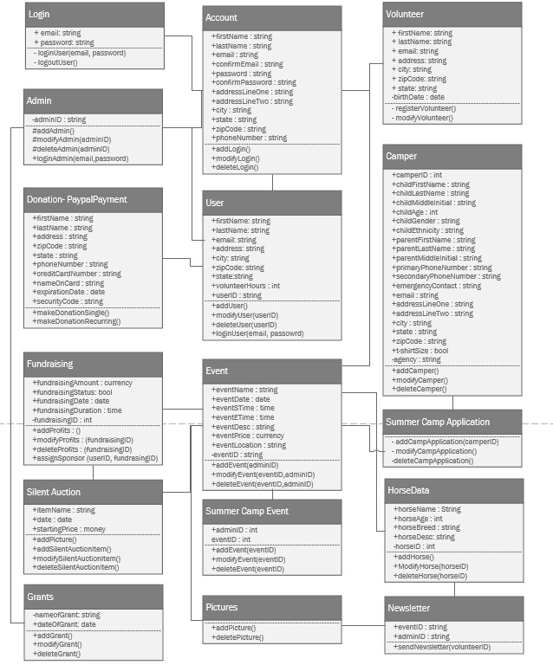

# Database design and data definitions

ERD graphically indicates information of the relationships between the system entities.

**ERD:**

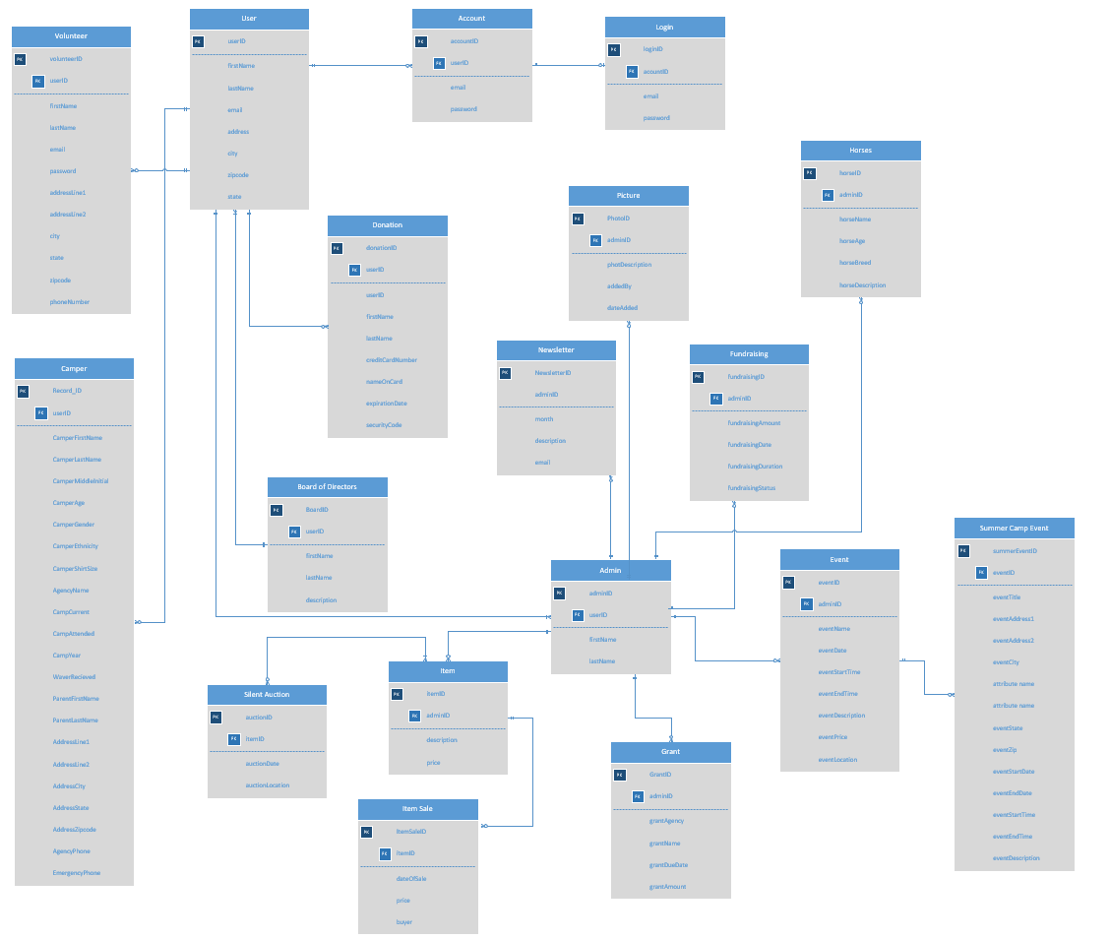

How to read data dictionary tables

A data dictionary table is a set of information that describes database entities and their relationships to each other. There are 6 columns on each table.The entity name is the name of the entity, followed by a short description of that entity. Next is the attribute name and the attribute definition. Attributes are values of an entity. The data type and size of the data are the lat two columns of the table. The purpose of the data dictionary is to make sure the database designer has enough information to make the database tables and fields.

## 

## 

## 

## 

## 

## 

## 

## 

## 

## 

## Camper Record

|  |  |  |  |  |  |
| --- | --- | --- | --- | --- | --- |
| **Entity Name** | **Entity Description** | **Attribute Name** | **Attribute Definition** | **Date Type** | **Size** |
| **Camper Record** | A record of a camper’s information. | **Record_ID**  (PK) | Unique identifier for camper record | Char | 10 |
|  |  | camperFirstName | First name of camper | String | 25 |
|  |  | camperLastName | Last name of camper | String | 25 |
|  |  | camperMiddleInitial | Middle Initial of camper | String | 1 |
|  |  | camperAge | Age of camper | Char | 2 |
|  |  | camperGender | Gender of camper | String | 1 |
|  |  | camperEthinicity | Ethnicity of camper | String | 15 |
|  |  | camperShirtSize | T-shirt size of camper | String | 5 |
|  |  | agencyName | Name of agency camper is from | String | 25 |
|  |  | campCurrent | Current summer camp the camper is attending | String | 25 |
|  |  | campAttended | Past summer camps the camper has attended | String | 25 |
|  |  | campYear | Year of the current summer camp the camper is attending | Char | 4 |
|  |  | waverRecieved | Validates if camper’s waiver is received | Bool | 2 |
|  |  | parentFirstName | First name of parent | String | 25 |
|  |  | parentLastName | Last name of parent | String | 25 |
|  |  | addressLine1 | First address line of parent’s address | String | 25 |
|  |  | addressLine2 | Second address line of parent’s address | String | 25 |
|  |  | addressCity | City of parent’s address | String | 25 |
|  |  | addressState | State of parent’s address | String | 25 |
|  |  | addressZipcode | Zip code of parent’s address | Char | 10 |
|  |  | agencyPhone | Phone number of agency | Char | 10 |
|  |  | emergencyPhone | Emergency contact phone numbers | Char | 10 |
|  |  |  |  |  | **TOTAL SIZE**  345 |

## Summer Camp Event

|  |  |  |  |  |  |
| --- | --- | --- | --- | --- | --- |
| Entity Name | Entity Description | Attribute Name | Attribute Definition | Data Type | Size |
| **Summer Camp Event** | An event that takes place in summer camp | **summerEventID**  (PK) | Unique identifier for event | Char | 10 |
|  |  | eventTitle | Title of the event | String | 25 |
|  |  | eventAddress1 | Address line 1 of the event | String | 25 |
|  |  | eventAddress2 | Address line 2 of the event | String | 25 |
|  |  | eventCity | City of the event | String | 25 |
|  |  | eventState | State of the event | String | 2 |
|  |  | eventZip | Zip code of the event | Char | 10 |
|  |  | eventStartDate | Start date of the event | Char | 10 |
|  |  | eventEndDate | End date of the event | Char | 10 |
|  |  | eventStartTime | Start time of the event | Char | 5 |
|  |  | eventEndTime | End time of the event | Char | 5 |
|  |  | eventDescription | Description of the event | String | 100 |
|  |  |  |  |  | **TOTAL SIZE**  252 |

## Volunteer Record

|  |  |  |  |  |  |
| --- | --- | --- | --- | --- | --- |
| **Entity Name** | **Entity Description** | **Attribute Name** | **Attribute Defintion** | **Date Type** | **Size** |
| **Volunteer** | A record of a volunteer’s information. | **volunteerID** (PK) | Unique Identification number | Integer | 10 |
|  |  | firstName | First name of volunteer | String | 25 |
|  |  | lastName | Last name of volunteer | String | 25 |
|  |  | email | Email of Volunteer (Login username) | String | 25 |
|  |  | password | Password for account login | String | 15 |
|  |  | addressLine1 | Address of volunteer | String | 25 |
|  |  | addressLine2 | Address of volunteer | String | 25 |
|  |  | city | City of volunteer | String | 25 |
|  |  | state | State of volunteer | String | 2 |
|  |  | Zipcode | Zip code of volunteer | String | 9 |
|  |  | phoneNumber | Phone number of volunteer | String | 10 |
|  |  |  |  |  | **Total Size:**  196 |

## Picture Record

|  |  |  |  |  |  |
| --- | --- | --- | --- | --- | --- |
| **Entity Name** | **Entity Description** | **Attribute Name** | **Attribute Defintion** | **Date Type** | **Size** |
| Photo | Photo uploaded to website | **Photo_ID** (PK) | Unique identifier for photo | int | 10 |
|  |  | Photo_Desc | Description of what the photo is about | string | 500 |
|  |  | Added_By | Who uploaded the photo | string | 20 |
|  |  | Date_Added | When the photo was uploaded | string | 10 |
|  |  |  |  |  | **Total Size:**  540 |

## Board of Directors Record

|  |  |  |  |  |  |
| --- | --- | --- | --- | --- | --- |
| **Entity Name** | **Entity Description** | **Attribute Name** | **Attribute Defintion** | **Date Type** | **Size** |
| **Board of directors** | Board member profile | **Board_ID** (PK) | Unique identifier for Board Members | int | 10 |
|  |  | First name | First name of board member | string | 20 |
|  |  | Last name | Last name of board member | string | 20 |
|  |  | description | Description of board member | string | 500 |
|  |  |  |  |  | **Total Size:**  550 |

## Newsletter Record

|  |  |  |  |  |  |
| --- | --- | --- | --- | --- | --- |
| **Entity Name** | **Entity Description** | **Attribute Name** | **Attribute Defintion** | **Date Type** | **Size** |
| Newsletter | Page featuring newsletters | **Newsletter_ID** (PK) | Unique identifier for newsletter | int | 10 |
|  |  | Month | Month of newsletter | string | 10 |
|  |  | Description | Description of newsletter with link | string | 50 |
|  |  | Email | Email used to sign up for newsletter | string | 50 |
|  |  |  |  |  | **Total Size:**  120 |

## Item Record

|  |  |  |  |  |  |
| --- | --- | --- | --- | --- | --- |
| **Entity Name** | Entity Desciription | Attribute Name | Attribute Definition | Data Type | Size |
| Item | A record of transactions in the Silent Auction. | **Item_ID**  (PK) | Unique identification number for item | Int | 10 |
|  |  | Date_Of_Sale | Date item is sold | Date | 10 |
|  |  | ItemPrice | Price of item | Decimal | (19,4) |
|  |  | buyerName | Name of buyer | String | 15 |
|  |  | donorName | Name of donor of item | String | 15 |
|  |  |  |  |  | **Total Size:**  73 |

## 

## 

## Grant Record

|  |  |  |  |  |  |
| --- | --- | --- | --- | --- | --- |
| **Entity Name** | Entity Desciription | Attribute Name | Attribute Definition | Data Type | Size |
| **Grant** | A record of grants | **Grant_ID**  (PK) | Unique identification number for grant | Int | 10 |
|  |  | grantAgency | Name of the grant agency | string | 15 |
|  |  | grantName | Name of grant | string | 15 |
|  |  | grantDate | Date grant was recieved | date | 10 |
|  |  | grantAmount | Amount of grant | decimal | (19,4) |
|  |  |  |  |  | **Total Size:**  73 |

## Item Sale Record

|  |  |  |  |  |  |
| --- | --- | --- | --- | --- | --- |
| Entity Name | Entity Description | Attribute Name | Attribute Description | Data Type | Size |
| **Item Sale** | A record of items sold in Silent Auction | **Sale_ID**  (PK) | Unique identification number for item sale | Int | 10 |
|  |  | saleDescription | Description of item | string | 15 |
|  |  | saleName | Name of item on sale | string | 15 |
|  |  | saleDonor | Name of donor of the item | string | 10 |
|  |  | salePrice | Price item was sold for | decimal | (19,4) |
|  |  |  |  |  | **Total Size:**  73 |

## 

## Events

|  |  |  |  |  |  |
| --- | --- | --- | --- | --- | --- |
| Entity  Name | Entity Description | Attribute  Name | Attribute Description | Data  Type | Size(Byte) |
| **Event** | An event which HOOF hosts for donations or fundraising | **eventID**  (PK) | Unique identification number | integer | 2 |
|  |  | eventName | Name of the event | string | 50 |
|  |  | eventDate | Date of the event | date | 3 |
|  |  | eventStime | Start time of the event | time | 3 |
|  |  | eventEtime | End time of the event | time | 3 |
|  |  | eventDescription | Description of the event | string | 500 |
|  |  | eventPrice | Price for participation for the event | string | 4 |
|  |  | eventLocation | Location of the event | string | 100 |
|  |  |  |  |  | **Total Bytes**  665 |

## Fundraising

|  |  |  |  |  |  |
| --- | --- | --- | --- | --- | --- |
| **Entity**  **Name** | **Entity Description** | **Column**  **Name** | **Column Description** | **Data**  **Type** | **Size(Byte)** |
| **Fundraising** | An action by an admin to record funds | **fundraisingID**  (PK) | Unique identification number | integer | 2 |
|  |  | fundraisingAmount | Amount of funds gained from event | integer | 10 |
|  |  | fundraisingDate | Date of the fundraising | date | 3 |
|  |  | fundraisingDuration | Length of time of the fundraising | time | 3 |
|  |  | fundraisingStatus | Is the event still going on | bool | 2 |
|  |  |  |  |  | **Total Bits**  20 |

## 

## 

## 

## 

## Horse Data

|  |  |  |  |  |  |
| --- | --- | --- | --- | --- | --- |
| Entity  Name | Entity Description | Column  Name | Column Description | Data  Type | Size(Bits) |
| **HorseData** | Records HOOF’s horse information | **horseID**  (PK) | Unique identification number | integer | 2 |
|  |  | horseName | Horse’s Name | string | 25 |
|  |  | horseAge | Age of the horse | integer | 3 |
|  |  | horseBreed | Breed of the horse | string | 10 |
|  |  | horseDescription | Description of the horse | string | 500 |
|  |  |  |  |  | **Total Bits**  540 |

# 

# 

# 

# User Interface Navigation Diagram and Screen Layouts

Relational depictions for contents in the system project. The navigation diagram organizes contents to show a screen flow.

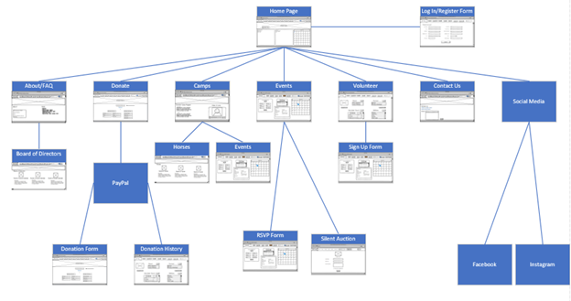

# Physical Architecture Design

## **Realization View**

Users are identified and interact with the HOOF website developed through WordPress and hosted on a server via SiteGround. Firewalls are in place to ensure the network is secure and serves as a barrier to untrusted networks such as the Internet. Data from the website is stored in the database for centralized access. Backup copies of the data are stored to protect and restore the database.

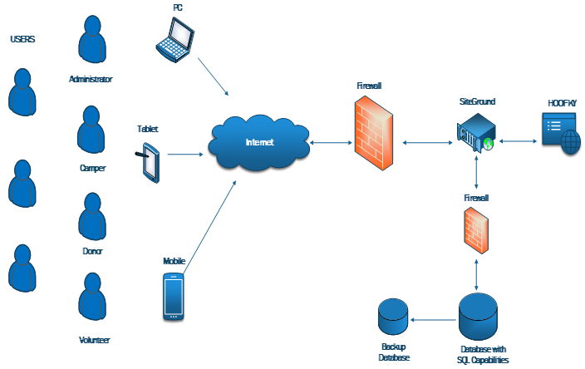

# Design Procedures for Security Concerns and Non-functional Requirements

Our Security - Staff at HOOF will have access to the system through the web browser of their choice. Users (staff, donors, etc.) will have to authenticate with the system by using their given username and password every time they want to log in.

Staff

Staff members will need to use both their username and password to login. Their username and password will authenticate who they are when they login.

Donor

Donors will need to use both their username and password to login. Their username and password will authenticate who they are when they login.

Volunteer

Volunteers will need to use both their username and password to login. Their username and password will authenticate who they are when they login.

IDrive Security

We plan on using IDrive for our online backup and security needs. IDrive provides affordable data/server backups and security for small businesses. IDrive has flexible plans that can be adjusted as HOOF’s needs change.

# 

# 

# Gantt Chart

This chart has the name of the task and the name of the group member performing the task to the left of the chart. Each task has a bar that indicated the length of the task, measured in days. Some tasks are independent and can be started whenever while others are dependent and require certain tasks be completed before they can be started. A dependent task is indicated by its starting point being at the end of another task instead of being on the first day like the other tasks. Where the bar starts indicates which task it depends on.

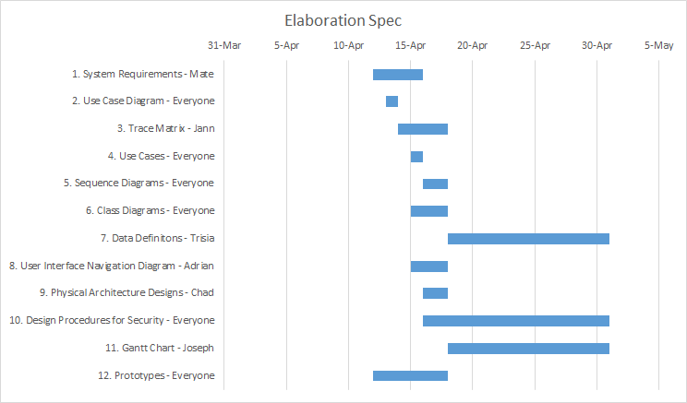

# Elaboration Phase Prototype

Prototypes shows the layout for an indicated business process and how it would look on a website.

## Add/Modify Camper Record

# 

## Delete Camper Record

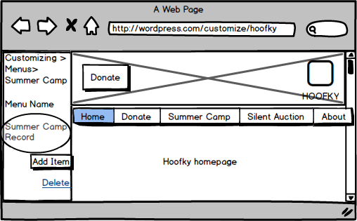

## Add/Modify Summer Camp Event

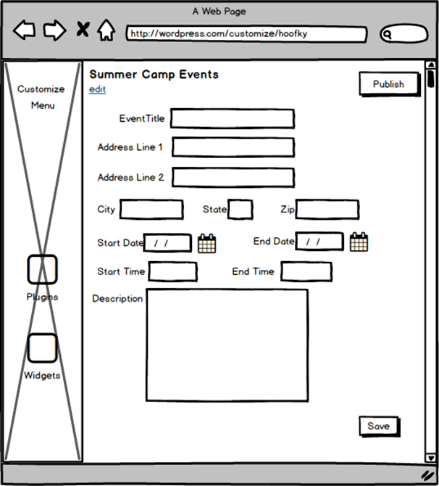

## 

## 

## 

## 

## Delete Summer Camp Event

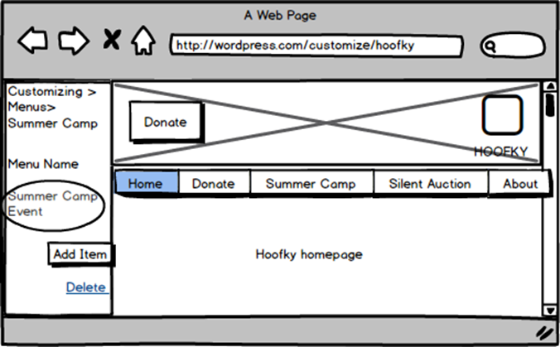

## View Summer Camp Event

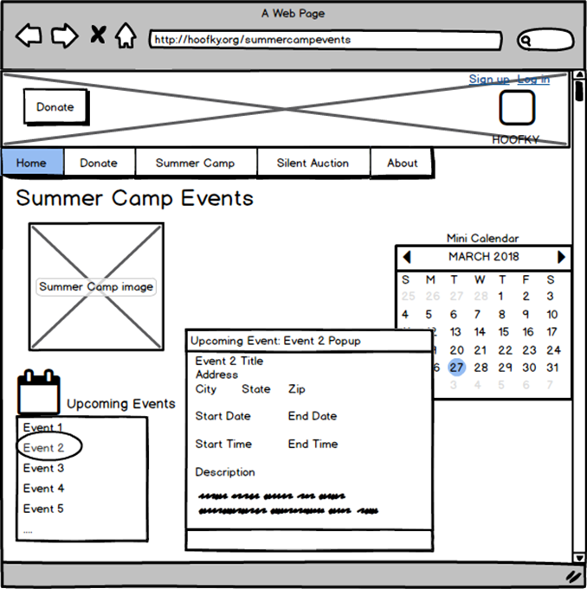

## Add Volunteer Record

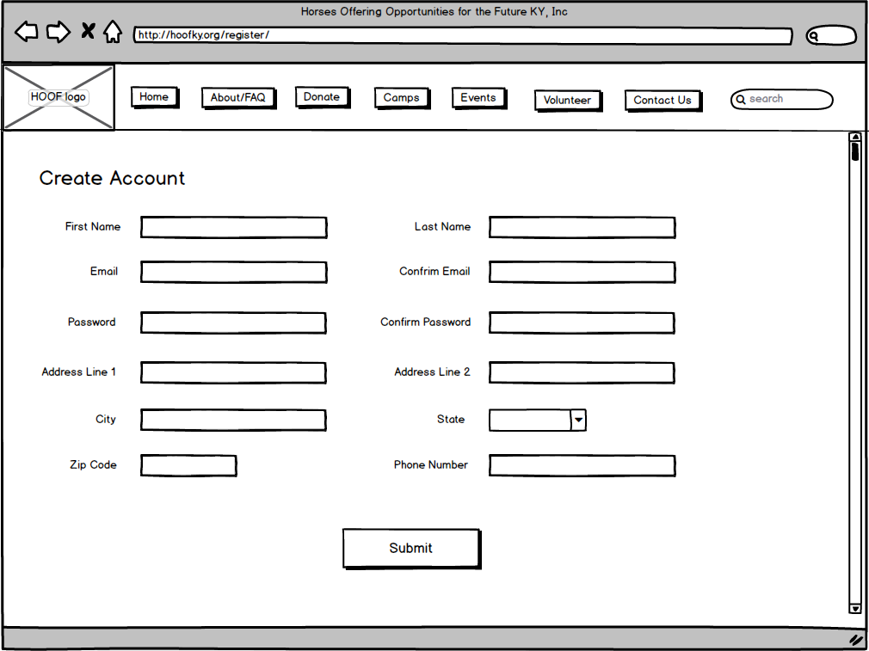

## Modify Volunteer

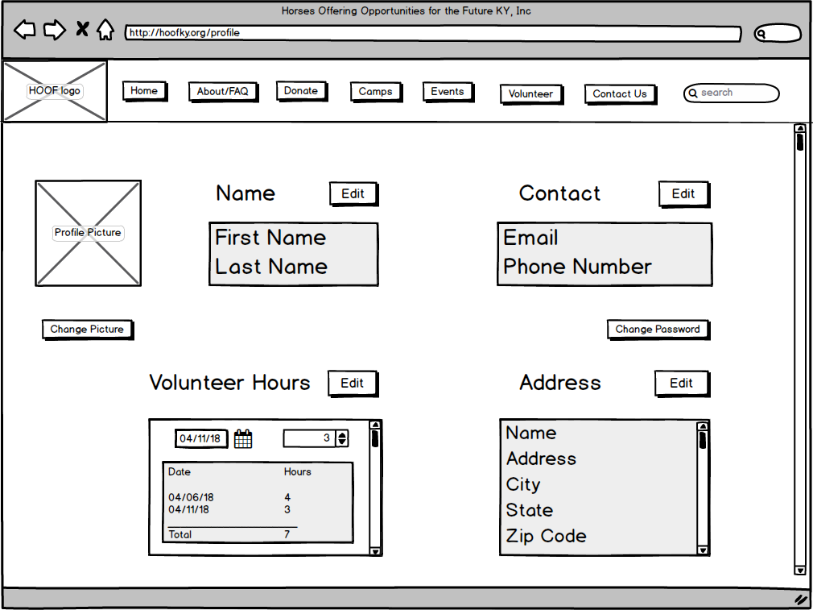

## Delete Volunteer

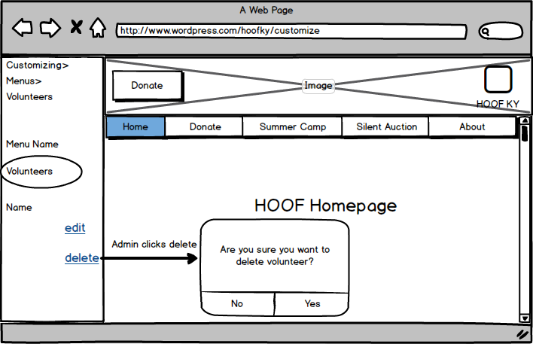

## Add/Modify/ Delete Events

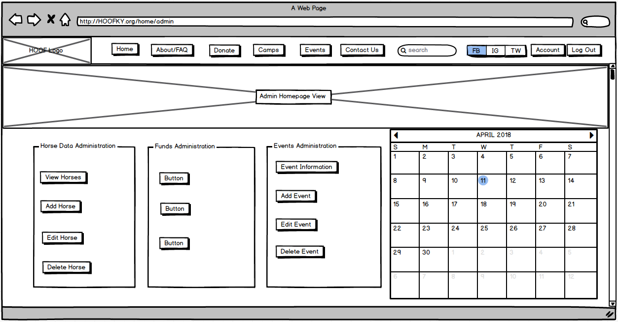

## View Events

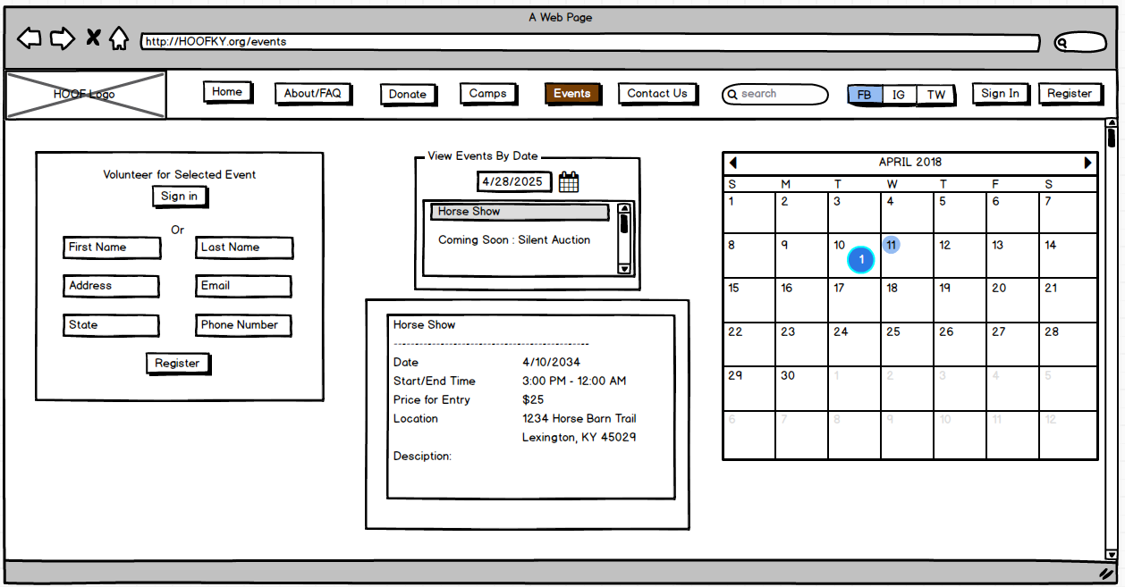

## View Horse Data

## Newsletter

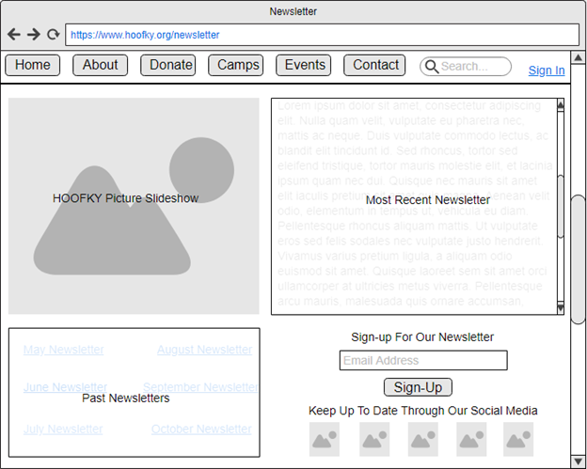

## Pictures

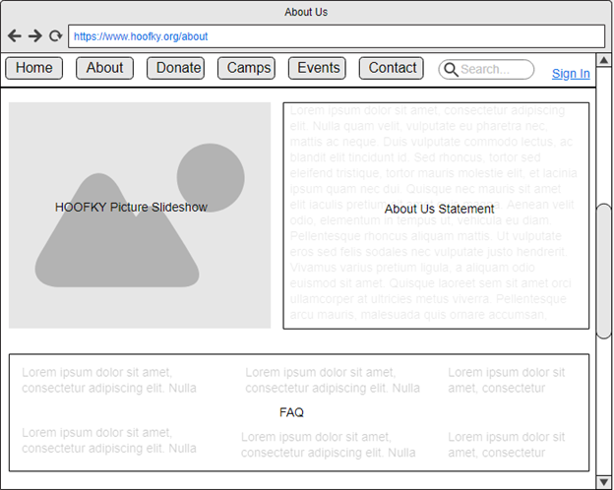

## Board of Directors

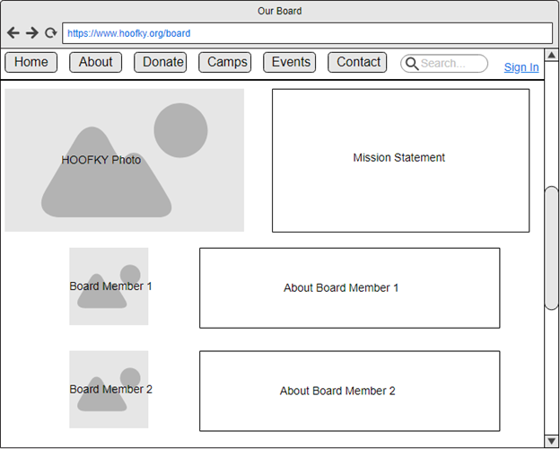

Add/Modify/Delete Item

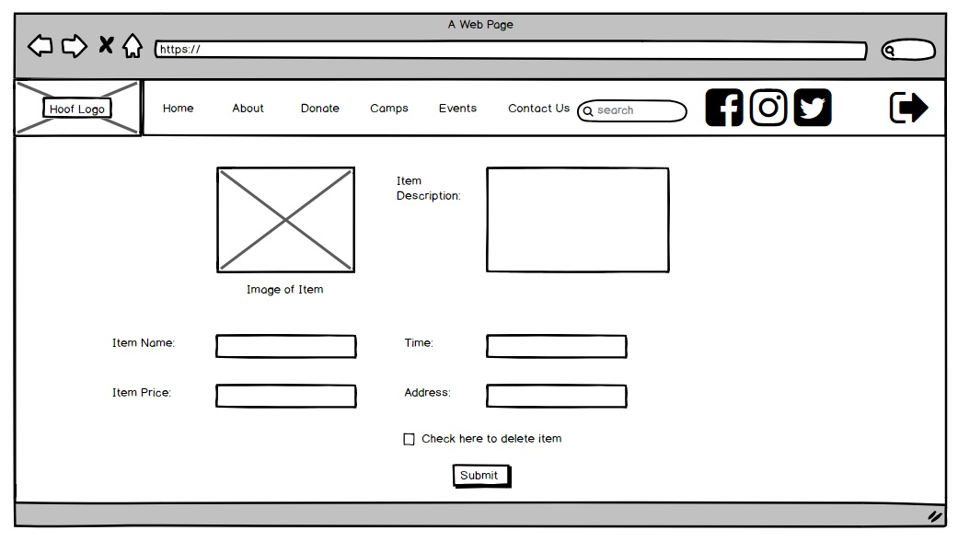

Add/Modify/Delete Sale

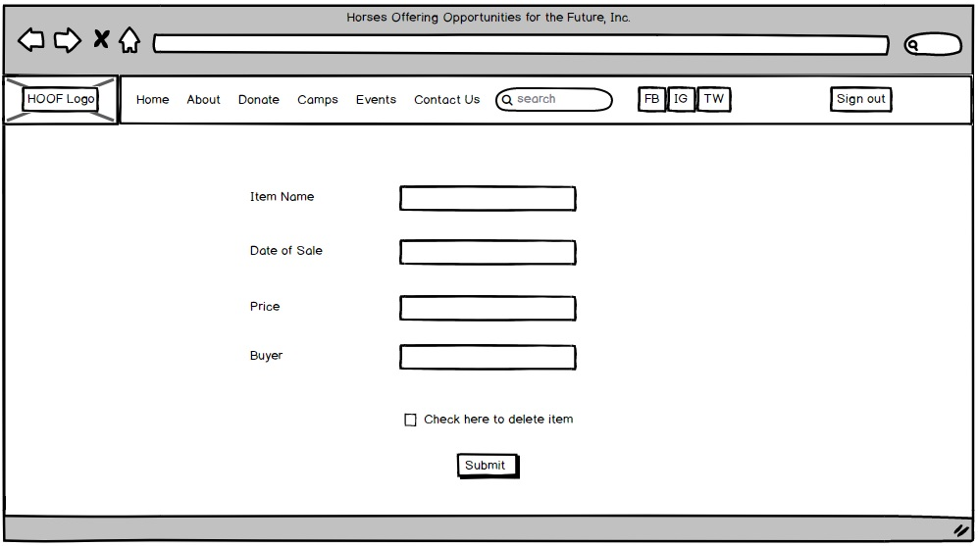

View Item

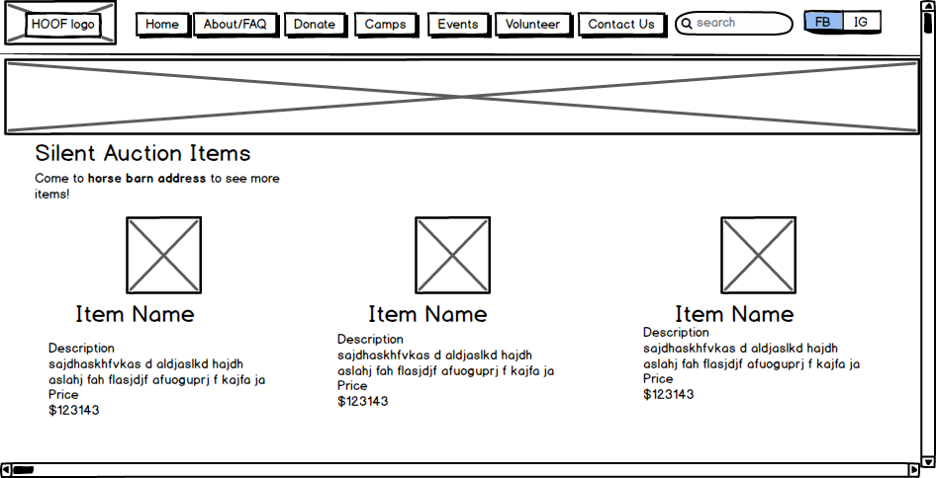

Add/Modify/Delete Grant Data

